

Industry placement employer incentive fund

Online data tool guidance

July 2021
Summary
This guidance has been produced for T Level providers delivering T Levels in 2020/21 and 2021/22 and provides the step-by-step process for submitting data for each employer incentive claim you receive onto the online tracking tool.

Expiry or review date

This guidance will expire on 31 July 2022

Who is this publication for?

This guidance is for T Level provider staff involved in administering the industry placement employer incentive fund

Overview

What does the tool do?
The online data tracking tool has been designed to track expenditure related to the employer incentive fund between the 27 May 2021 and 31 July 2022 and to collect information of the employers claiming the incentive payment.
The information provided will also be used to recover any underspend at the end of the academic year 2021/22. As stated in the funding rules, you are required to submit full and accurate information associated with all employer claims and ensure that the data on the online tool is completely up-to-date before the specific monitoring points, starting in September 2021 and every six weeks thereafter.
How to access the tool
To access the tool, you will need a DfE sign in account. Click on the link to the online form as provided and enter your DfE sign in account details to access the online form. Only T Level providers administering the employer incentive fund will have access to this form.
Multiple users from the same institution can access this online form, so long as they have DfE sign in details. If you do not have DfE sign in account, please visit DfE sign-in.
Once you have signed in, you will be asked to confirm that you have already made payment to the associated employer before you can begin completing the online form.
- Employer details page
You will first be asked to complete the employer details page. All the information required should be on the completed Employer Declaration form you will have received from the employer. Please note, all fields in this form are mandatory.
There are validation rules throughout this form to increase data accuracy. You will be notified by an error message where you have entered incorrect data on any page once you click ‘Continue’. We have noted the validation rules for each page.

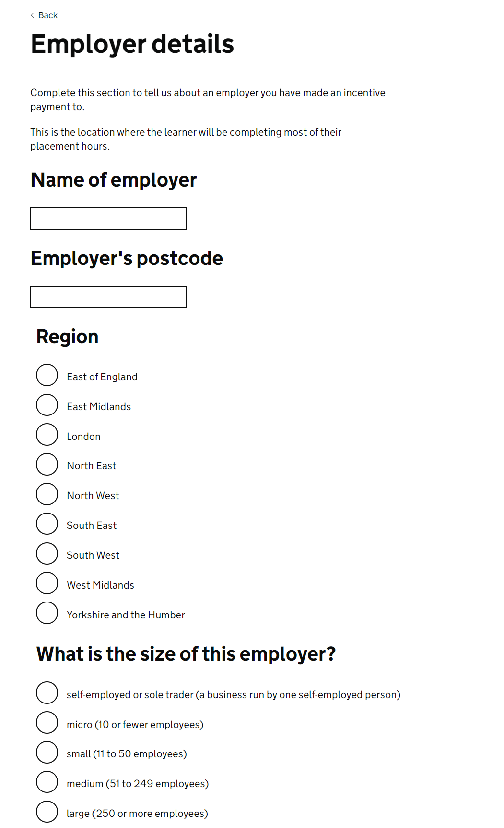
The region and size of employer are single selection radio buttons

Please enter the name of the employer and employer postcode in the free text boxes
NB: the post code field will only accept a post code typed in the correct format, such as S61 3RP

We have asked the two following questions as part of the employer declaration. Please select the appropriate box to confirm how they responded to these questions, then press ‘continue’.
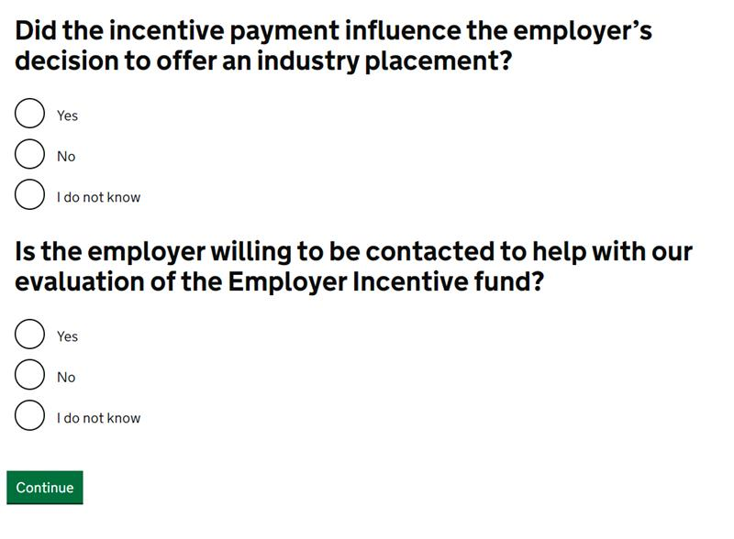

Add learners page

Each claim must include at least one T Level learner. You must include the learner’s details by clicking ‘Add Learner’.
If the employer is claiming for multiple students within the same claim, you can add more learners to the same claim form by clicking on ‘Add Learner’ until you have recorded all learners that the employer has agreed to have on placement. This is to avoid you from having to enter in the employer details multiple times for each placement offered.
NB: Please remember that employers can only claim for up to 20 placements within any one region. Once you have entered up to 20 learners for that single employer, the ‘add learner’ option will automatically be removed.
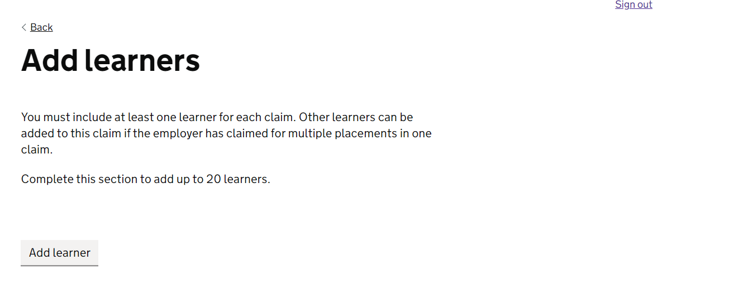
- Learner details page
For each learner listed, you will need to complete the manditory fields below, before clicking continue. After you have submitted the details you will be taken back to the ‘add learners’ page where you will see that the learner has been added to this claim. From this page, you can change or delete the learner record by clicking ‘back’ to amend the details or pressing the bin icon to delete and start again.

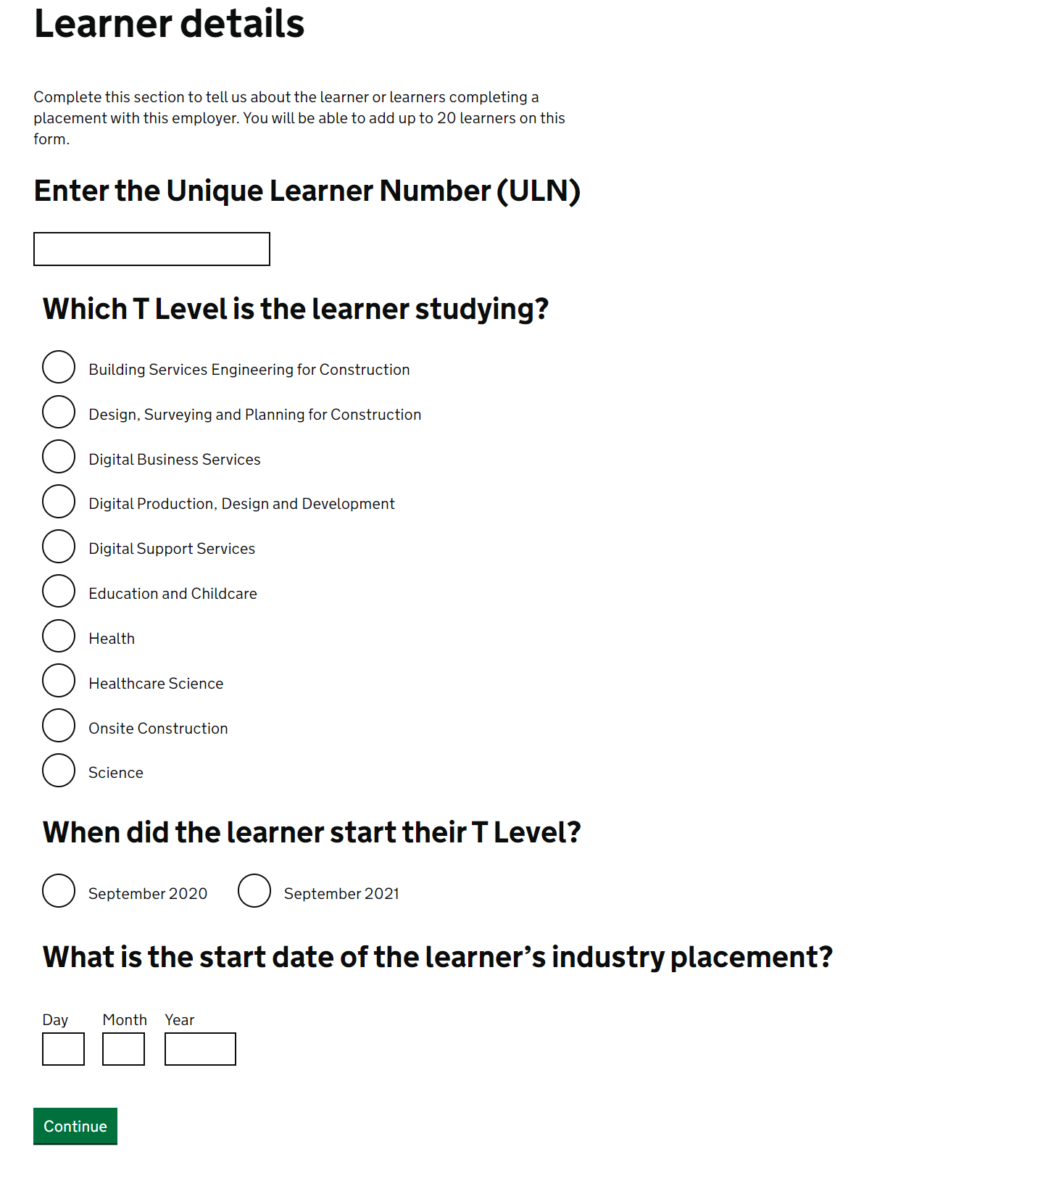
You must enter the student’s 10-digit Unique Learner Number
If you enter a number with less or more than 10 digits, the system will provide an error message and you will not be able to proceed without entering the 10 digit ULN
Please enter the agreed date when the placement is planned to start.
Validation checks:
- You will not be able to enter a date that pre-dates the 27 May 2021
- You will not be able to enter a date that pre-dates the 1 September 2021 if you selected September 2021 as the year the learner started their T Level
- You will not be able to enter a start date after the 31 July 2022.

Please select the correct year in which this learner started their T Level.

Please select the relevant T Level title that this learner is studying

- Employer Declaration upload page
You will be asked to upload the completed Employer Declaration Form for each claim submitted by an employer. You cannot complete the online tool unless you have uploaded this form.
You will only need to upload more than one Employer Declaration form if the employer has submitted multiple Employer Declaration Forms for multiple students.
If you have accidently uploaded the incorrect form, you can delete the uploaded record by clicking ‘back’ to amend the details or pressing the bin icon to delete and select the right file.
You can upload these files types:
- PDF
- JPG
- JPEG
- PNG
- .DOCX
- .DOC
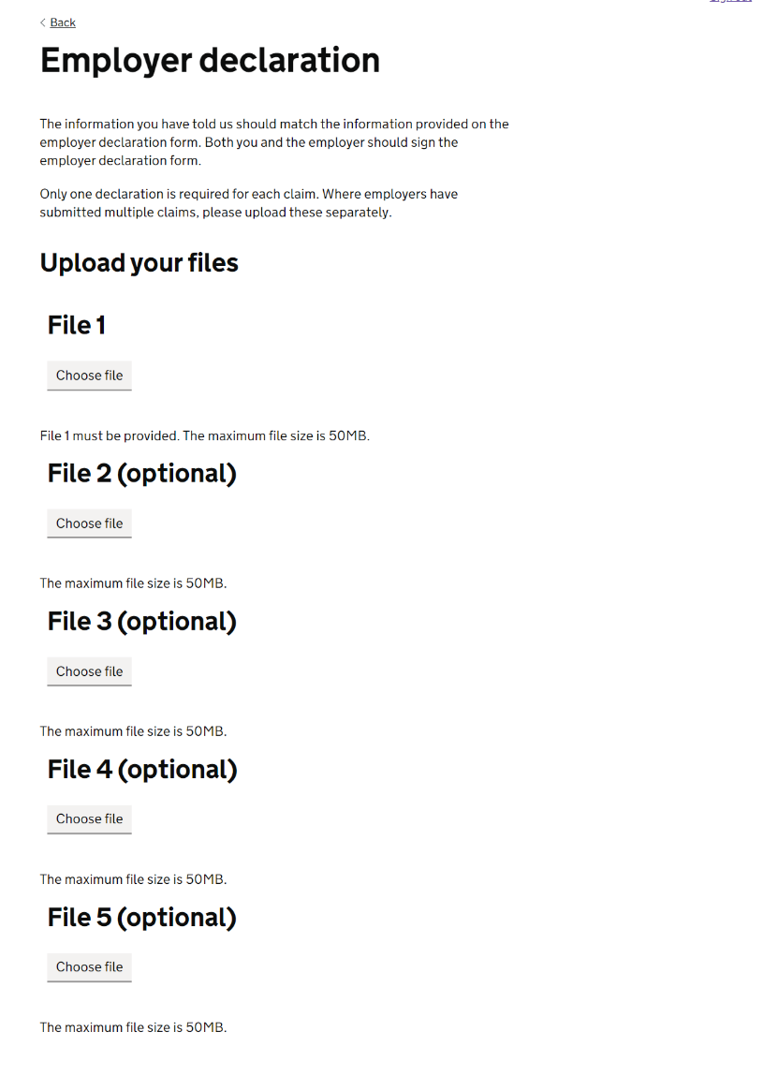
- Summary details page
You will then be taken to the next page that summaries the details that you have submitted. You must tick both Declaration boxes at end of the page before you submit the form. An error message will appear if both boxes haven’t been ticked.

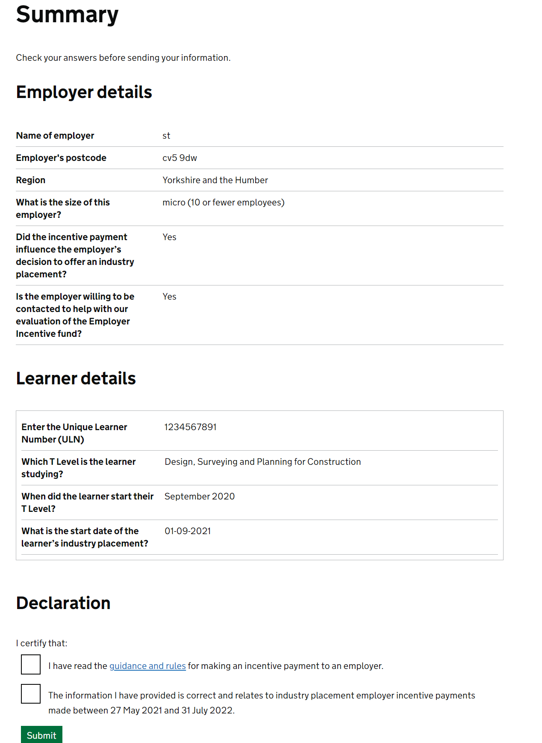

- Confirmation page

You will then be taken to this confirmation page and receive an email with the summary detail presented above. Please keep these confirmation emails for your own records. You can also down load a PDF copy of the submission details – it is recommended that you keep a copy of the PDF for your own records

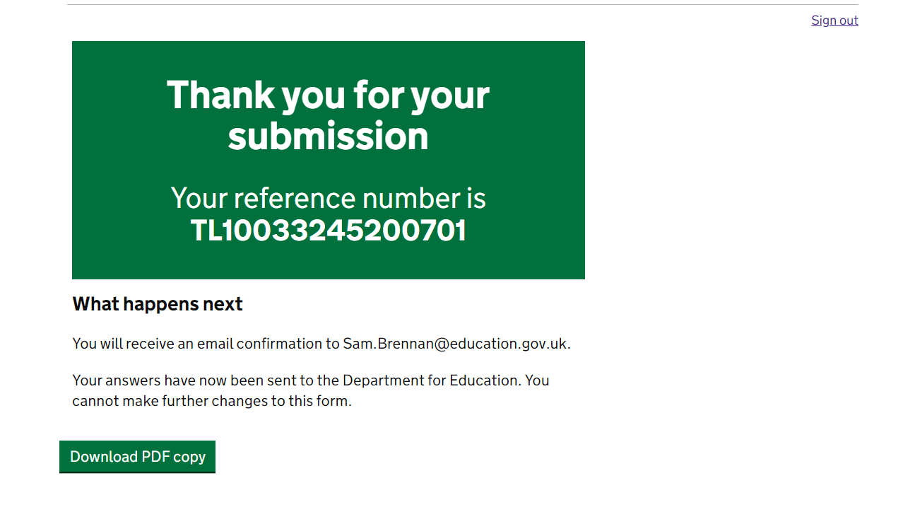

- Queries about this form

Any queries related to completing this online form, please contact: ip.employerincentivefund@education.gov.uk

